**Taxi Fare Prediction Analysis MySQL QUERY DOCUMENT**

**Taxi Fare Prediction | SUMMARY : BY Shivanand S Nashi**

**1.Total revenue generated:**

SELECT SUM(amount) AS total_revenue FROM taxifare;

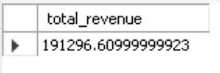

**2.Number of trips per passenger count:**

SELECT no_of_passenger, COUNT(*) AS trip_count

FROM taxifare

GROUP BY no_of_passenger

ORDER BY trip_count DESC;

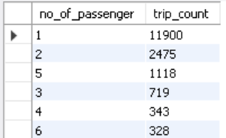

**3.Trips with the highest fare amount:**

SELECT *

FROM taxifare

ORDER BY amount DESC

LIMIT 10;

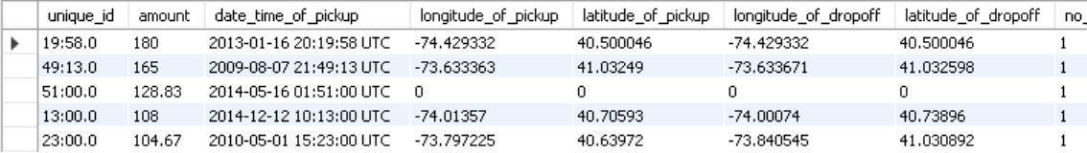

**4.Average fare amount by passenger count:**

SELECT no_of_passenger, AVG(amount) AS average_fare

FROM taxifare

GROUP BY no_of_passenger

ORDER BY average_fare DESC;

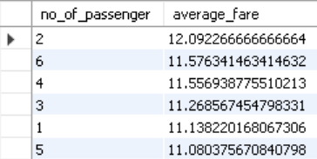

**5.Trips occurring during peak hours (7 AM - 9 AM and 5 PM - 7 PM):**

SELECT COUNT(*) AS peak_hour_trips

FROM taxifare

WHERE (HOUR(STR_TO_DATE(date_time_of_pickup, '%Y-%m-%d %H:%i:%s')) BETWEEN 7 AND 9)

   OR (HOUR(STR_TO_DATE(date_time_of_pickup, '%Y-%m-%d %H:%i:%s')) BETWEEN 17 AND 19);



**6.Identify outliers in the fare amount (e.g., trips with fare > $500):**

SELECT *

FROM taxifare

WHERE amount > 50;

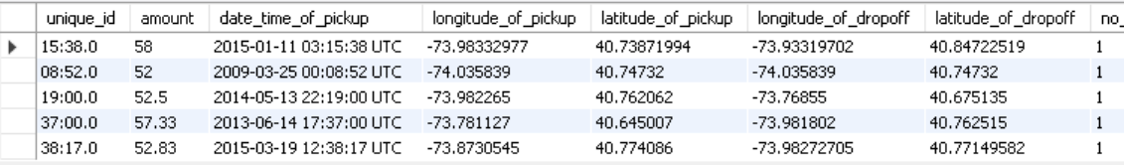

**7.Longest trip based on geographical coordinates (Haversine distance):**

SELECT unique_id,

       (3959 * ACOS(COS(RADIANS(latitude_of_pickup))

                  * COS(RADIANS(latitude_of_dropoff))

                  * COS(RADIANS(longitude_of_dropoff) - RADIANS(longitude_of_pickup))

                  + SIN(RADIANS(latitude_of_pickup))

                  * SIN(RADIANS(latitude_of_dropoff)))) AS distance

FROM taxifare

ORDER BY distance DESC

LIMIT 1;

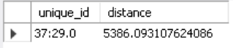

**8.Daily revenue trends:**

SELECT DATE(STR_TO_DATE(date_time_of_pickup, '%Y-%m-%d %H:%i:%s')) AS trip_date,

       SUM(amount) AS daily_revenue

FROM taxifare

GROUP BY trip_date

ORDER BY trip_date;

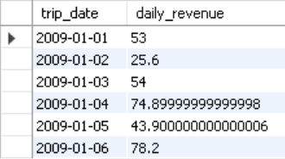

**9.Most frequent pickup and dropoff locations:**

SELECT longitude_of_pickup, latitude_of_pickup, COUNT(*) AS pickup_count

FROM taxifare

GROUP BY longitude_of_pickup, latitude_of_pickup

ORDER BY pickup_count DESC

LIMIT 10;

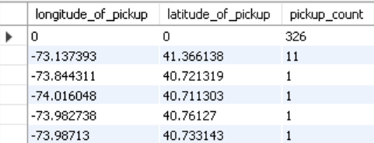

SELECT longitude_of_dropoff, latitude_of_dropoff, COUNT(*) AS dropoff_count

FROM taxifare

GROUP BY longitude_of_dropoff, latitude_of_dropoff

ORDER BY dropoff_count DESC

LIMIT 10;

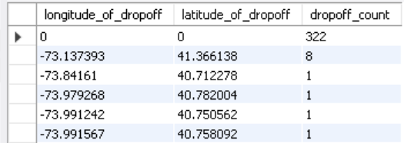

**10.Trips during weekends vs. weekdays:**

SELECT CASE

         WHEN WEEKDAY(STR_TO_DATE(date_time_of_pickup, '%Y-%m-%d %H:%i:%s')) IN (5, 6) THEN 'Weekend'

         ELSE 'Weekday'

       END AS day_type,

       COUNT(*) AS trip_count

FROM taxifare

GROUP BY day_type;

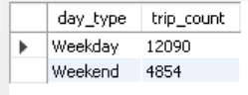

**11.Top 5 dates with the highest total revenue:**

SELECT DATE(STR_TO_DATE(date_time_of_pickup, '%Y-%m-%d %H:%i:%s')) AS trip_date,

       SUM(amount) AS total_revenue

FROM taxifare

GROUP BY trip_date

ORDER BY total_revenue DESC

LIMIT 5;

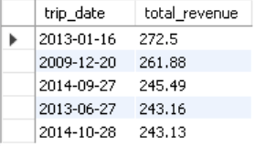

**12.Trips with more than 3 passengers and fare above $50:**

SELECT *

FROM taxifare

WHERE no_of_passenger > 3 AND amount > 50;

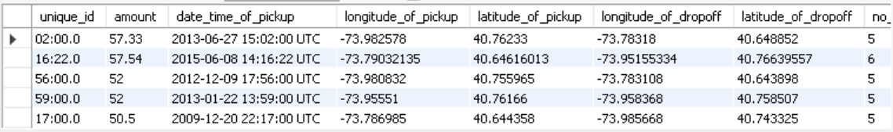

**13.Hourly distribution of trips:**

SELECT HOUR(STR_TO_DATE(date_time_of_pickup, '%Y-%m-%d %H:%i:%s')) AS trip_hour,

       COUNT(*) AS trip_count

FROM taxifare

GROUP BY trip_hour

ORDER BY trip_hour;

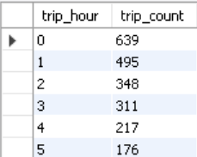

**14. Average fare amount per trip distance bucket (short, medium, long):**

**# Assuming distances are pre-calculated in buckets:**

SELECT CASE

         WHEN distance <= 2 THEN 'Short (<=2 miles)'

         WHEN distance > 2 AND distance <= 5 THEN 'Medium (2-5 miles)'

         ELSE 'Long (>5 miles)'

       END AS distance_category,

       AVG(amount) AS average_fare

FROM (

      SELECT *,

             (3959 * ACOS(COS(RADIANS(latitude_of_pickup))

                      * COS(RADIANS(latitude_of_dropoff))

                      * COS(RADIANS(longitude_of_dropoff) - RADIANS(longitude_of_pickup))

                      + SIN(RADIANS(latitude_of_pickup))

                      * SIN(RADIANS(latitude_of_dropoff)))) AS distance

      FROM taxifare

     ) AS trips

GROUP BY distance_category;

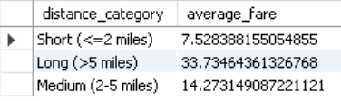

**15. Most expensive trip per passenger count:**

SELECT no_of_passenger, MAX(amount) AS max_fare

FROM taxifare

GROUP BY no_of_passenger

ORDER BY max_fare DESC;

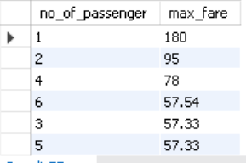

**16.Trips with identical pickup and dropoff locations:**

SELECT *

FROM taxifare

WHERE longitude_of_pickup = longitude_of_dropoff

  AND latitude_of_pickup = latitude_of_dropoff;

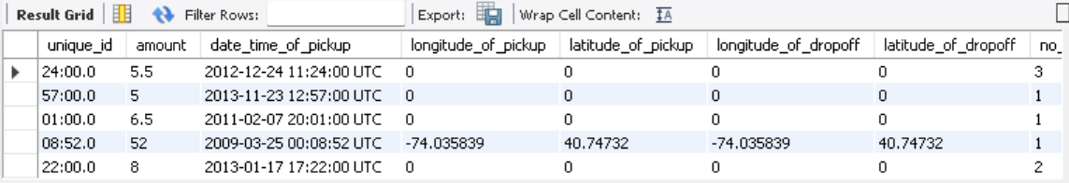

**17.Trips with multiple passengers but a fare below the average fare:**

SELECT *

FROM taxifare

WHERE no_of_passenger > 1

  AND amount < (SELECT AVG(amount) FROM taxifare);

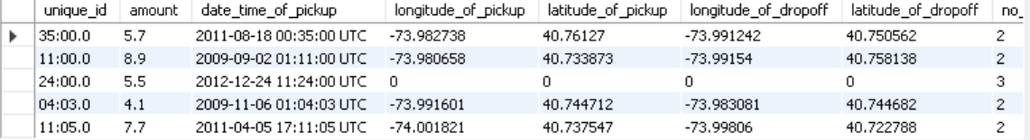

**18.Revenue generated by each unique pickup location:**

SELECT longitude_of_pickup, latitude_of_pickup,

       SUM(amount) AS total_revenue

FROM taxifare

GROUP BY longitude_of_pickup, latitude_of_pickup

ORDER BY total_revenue DESC

LIMIT 10;

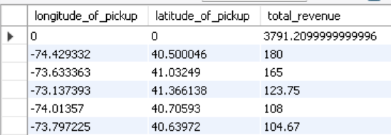

**19. Identify trips with an unusually high fare for the distance traveled:**

WITH TripDetails AS (

SELECT *,

(3959 * ACOS(COS(RADIANS(latitude_of_pickup))

* COS(RADIANS(latitude_of_dropoff))

* COS(RADIANS(longitude_of_dropoff) - RADIANS(longitude_of_pickup))

+ SIN(RADIANS(latitude_of_pickup))

* SIN(RADIANS(latitude_of_dropoff)))) AS distance

FROM taxifare

)

SELECT *,

(amount / distance) AS fare_per_mile

FROM Tripletail’s

WHERE (amount / distance) > 100

AND distance > 0;

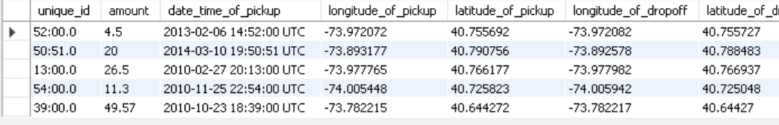

**20. Trips with the longest travel time:**

WITH TravelTime AS (

SELECT *,

TIMESTAMPDIFF(MINUTE, latitude_of_pickup,latitude_of_dropoff) AS travel_time_minutes

FROM taxifare

)

SELECT *

FROM TravelTime

ORDER BY travel_time_minutes DESC

LIMIT 10;

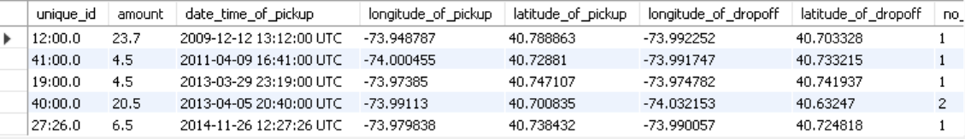

**21.Monthly trends in the number of trips:**

SELECT DATE_FORMAT(STR_TO_DATE(date_time_of_pickup, '%Y-%m-%d %H:%i:%s'), '%Y-%m') AS trip_month,

COUNT(*) AS trip_count

FROM taxifare

GROUP BY trip_month

ORDER BY trip_month;

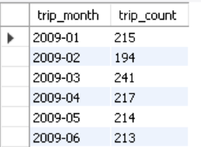

**22.Top 10 drop-off locations by fare amount:**

SELECT longitude_of_dropoff, latitude_of_dropoff,

       SUM(amount) AS total_revenue

FROM taxifare

GROUP BY longitude_of_dropoff, latitude_of_dropoff

ORDER BY total_revenue DESC

LIMIT 10;

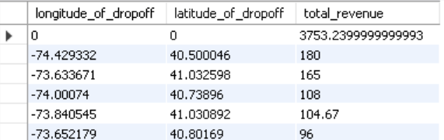

**23.Average distance traveled by trip based on the number of passengers:**

SELECT no_of_passenger,

       AVG(3959 * ACOS(COS(RADIANS(latitude_of_pickup))

                     * COS(RADIANS(latitude_of_dropoff))

                     * COS(RADIANS(longitude_of_dropoff) - RADIANS(longitude_of_pickup))

                     + SIN(RADIANS(latitude_of_pickup))

                     * SIN(RADIANS(latitude_of_dropoff)))) AS average_distance

FROM taxi_fare

GROUP BY no_of_passenger

ORDER BY average_distance DESC;

